EXPERIMENT -12
Hypothetical using Z-Test
Aim:
To test whether the average weight of species of bird differs from 150 grams
Procedure:
- Null hypothesis
- Alternative hypothesis
- Sample
- Z-Test
- Decision Rule

Program:
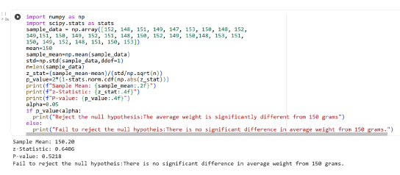

Result:
Thus the python program for doing hypothetical test using Z-Test is executed and output is verified successfully

